Name: Shreyasi Gidmare

PRN:23070521146 Batch: B2

Practical 09 – Final Task

Aim
Implement a Personalized Dashboard that uses both localStorage and sessionStorage to remember user settings and temporary state.

Scenario
You are creating a “Personal Dashboard” that remembers a user’s:
- Name (persistent)
- Theme (light/dark)
- Font size (small/medium/large)
- Temporary visit count (session-only)
- Feedback message draft (session-only)

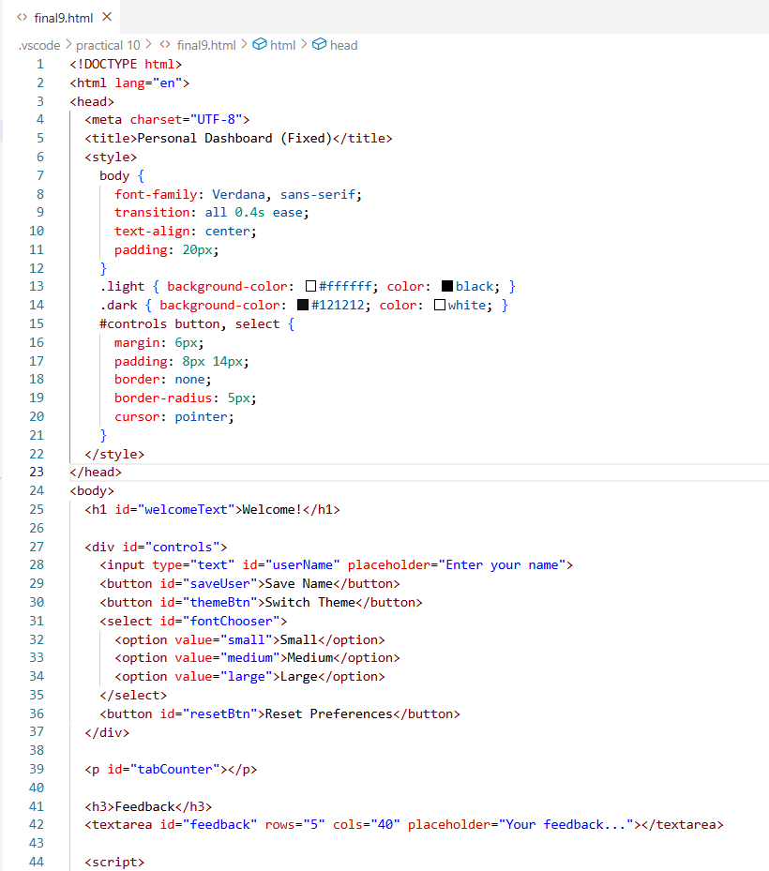

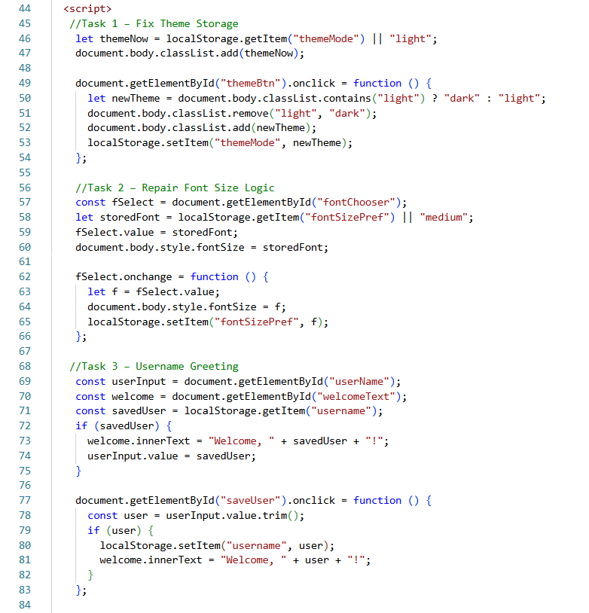

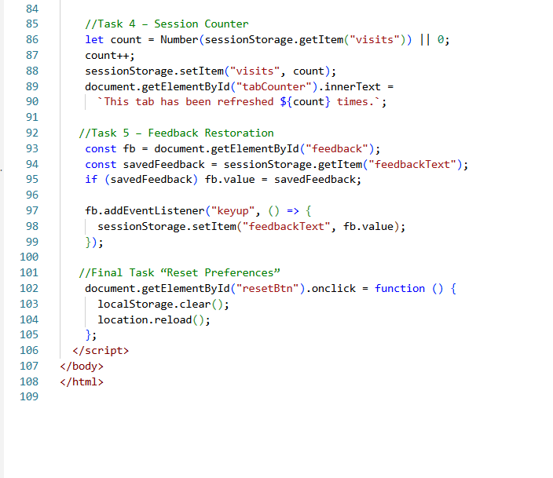

Output :
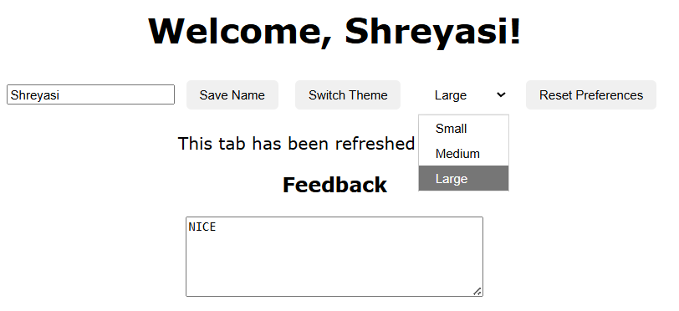
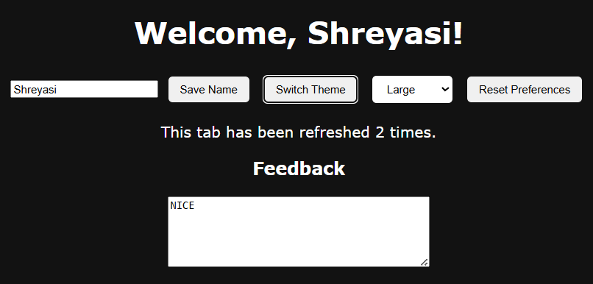
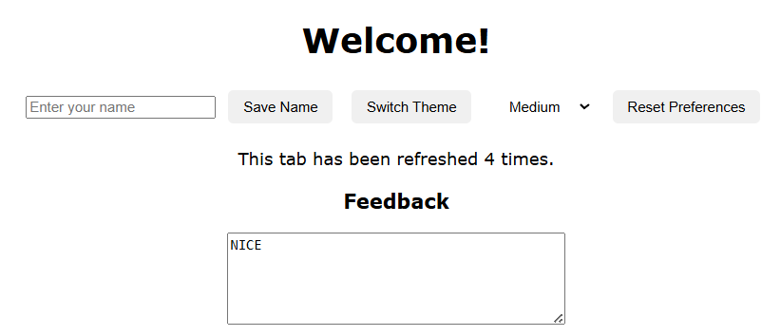
Unified key name to "theme", defaulted to light mode, fixed invalid classList = t; by using classList.add/remove.
• Font Size:
Made storage key consistent ("fontsizePref"), mapped size names to pixel values, and ensured persistence.
• Username:
Used a single key "username" for both save/load and added auto-display on reload.
• Session Counter:
Corrected increment logic using Number() and count + 1.
• Feedback:
Used textarea.value instead of innerHTML and restored text on reload.
• Reset Button:
Added “Reset Preferences” to clear localStorage and reload the page
Issues & Justifications
- Inconsistent keys (e.g., ThemeMode vs theme, fontsizePref vs fontSizePref) → Data didn’t persist.
- Wrong classList usage → Invalid theme switching.
- Mixed localStorage methods (localStorage.name vs getItem()) → Username not saved.
- No type conversion in counter → Wrong refresh count.
- Used .innerHTML for textarea → Feedback not saved.
- Missing restore logic → Saved settings not loaded on reload.

